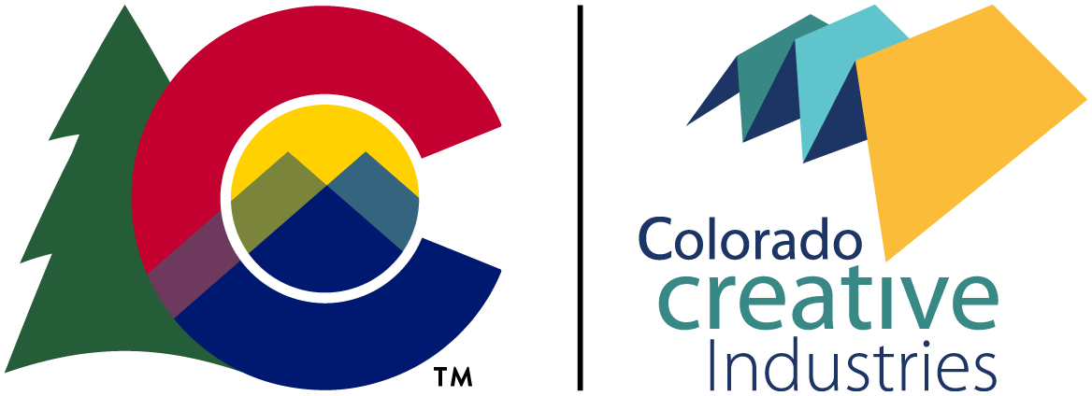

Colorado Creative Corps ARP Grant Application Materials

All users are required to log into the portal and complete the online application for Colorado Creative Corps ARP Grant. All support materials are uploaded into the online Colorado Creative Industries Grant Portal. New users will need to register for an account on the portal.

No hard copies or emailed copies of the application or support materials will be accepted. We recommend that applicants register in the portal and review the online grant system with plenty of time before the deadline to allow staff proper time to assist with any questions or issues.

Overview of this document:
- How to create an account in the application portal
- Required documents
- Application questions
- Staff contact information

How to create an account in the application portal

Each organization should have only one organization account assigned to a Primary Administrator. This administrator can add members to the organization and give access to applications. If registering for an account in the grant portal for the first time, there are 3 steps to complete:
- Register as an individual or organization.
- Verify your email address.
- Complete the eligibility quiz.

Each time a user logs into the portal, the system defaults to the individual account. If you are trying to access organization applications, you will need to switch to the organization account by selecting your name in the upper left corner.

For more support setting your account, please review these additional Colorado Creative Industries Grant Portal Instructions.

To successfully submit your application, all tasks must be completed and then the submit button will be available. A confirmation email will be sent upon a successful submission.

Required documents

All documents need to be submitted in this format: “ORGANIZATION NAME_descriptive title.”

Project budget form
The budget should include:
- artist fees and stipends (providing presentations, workshops, and research with tangible outcomes required by the project are allowable and considered part of the artist fee or stipend)
- the cost to carry out specific projects and activities
- the cost of materials and supplies to carry out the project

Up to 5 samples of previous work
Submit a Word or PDF file that includes an inventory of work sample information (title, date, medium, size). Samples:
- should demonstrate the artistic excellence of the applicant and any collaborating artists or organizations associated with this project
- should clearly support the project narrative and may include video of live performances, audio clips of music, images of artistic work, and writing samples
- can be audio or video samples of a performance (up to 3 minutes), photo documentation of visual artworks, and short excerpts from a publication in a PDF format

Application questions

Each question in the online application allows for 350 words. To fill out the application, you will need to:
- Prepare answers to the narrative questions in a word processing or notepad document.
- Check the word count for each question. To check your word count in Microsoft Word, select all of the words in your response, select ‘Tools’, and select ‘Word Count’.
- Cut-and-paste each response into the online application in the Colorado Creative Industries Grants Portal.

We recommend filling in your answers in this document and saving your progress. You can copy and paste your responses from this document into the application portal when you are ready.

- Describe the project and the community that will benefit from it.

- Describe your artistic practice and interest in this project.

- List the partners involved (ie artist(s), local organizations, advisors, etc.) and describe their roles. If certain partners have not yet been identified, describe the process for selecting partners.

- Describe where the proposed artwork will be located or occur. How will the artwork product and/or creation process be accessible to the public or a defined community?

- Please outline the timeline for the project with milestones?

- How will success be determined?

Staff contacts

Applicants seeking assistance are advised to contact Colorado Creative Industries staff well in advance of the application deadline. Prior to contacting a staff member, you should read the guidelines thoroughly.

For questions regarding the Colorado Community Revitalization Grant program, email Libby Barbee. For questions regarding the application portal, email Christy Costello.

